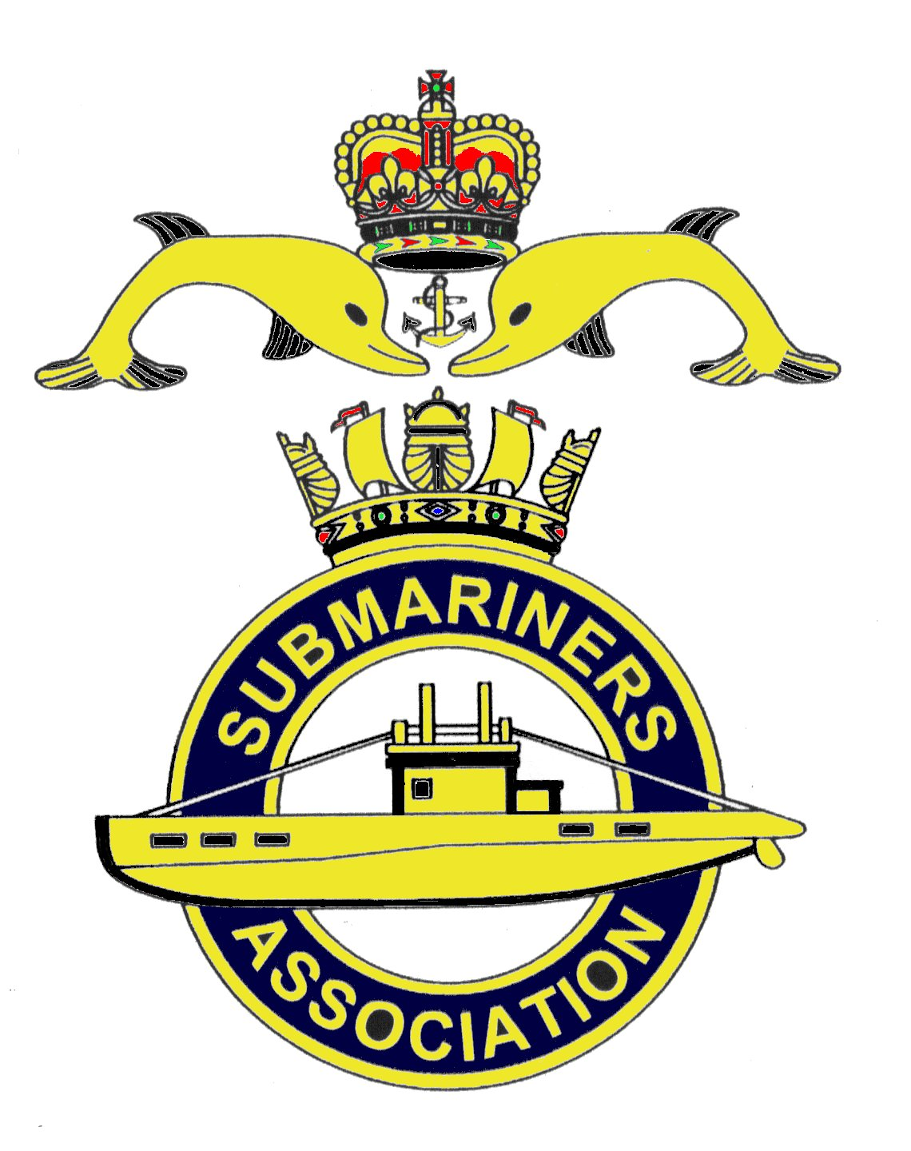  Lincoln Branch | Minutes of monthly meeting of Lincoln Submariners Association  At  The RNA Club  16th September 2018

- The Chairman opened the meeting at :- 1230

- Members present :- 11

- Apologies:- R.Elrick, M.Brockelsby, D.Bussey, J.Serdecki, A.Jeffrey, J.Hobson, A.Last.

- Obituaries:- The Obituary table containing all those that have "Crossed the Bar" in the last month was passed round for all to read. A minutes silence was held after which our prayer was said.

- Minutes of the last meeting: The minutes of the last meeting were accepted as a true record.
- Matters arising: There were no matters arising.

- Chairman’s Report:-
1) The Chairman informed the meeting that the branch Mobility Scooter had been placed on "Gum Tree" for sale, with a price of £300. There have been three enquiries of interest so far, but no
sale yet.

- Correspondence:-
1) Letter from Blackpool and Fylde Branch was read out to the meeting. This letter registers their objections to the proposal made by RASM. Rear Admiral Weale.OBE. at the National Council
Conference held at Kegworth on 24th March 2018. In which he "proposed to award Dolphins to
trainees before they go to sea". ( Blackpool and Fylde's letter is attached )
In response T.Eynon said that he thought that "they ( Blackpool and Fylde ) had missed the boat on
this one". Going on to reiterate what he had said at the April meeting, regarding the role that
virtual reality now plays in training. "It is going to happen".
The Chairman followed this by saying that the majority of the NMC basically agree with what is said
in the letter, and that the National Chairman has responded to Blackpool and Fylde, and has forwarded
their letter to RASM. The ball is now in his court.
9. Secretaries Report:-
1) Members were informed of the annual Concert of Remembrance given by the "Lincolnshire
Fire and Rescue Concert Band" at Sir Robert Pattinson Academy, North Hykeham on Friday 9th November 2018. Doors open at 1845. Admission £5 contribution. Our Standard will be paraded.
2) Remembrance Day Service at Lincoln Cathedral at 1040 on Sunday 11th November 2018.
M.Williams has sent out an e-mail to you all urging that as many as possible attend this service. If you
are going, please give your name to Mike so that he can inform the verger so that seats can be allocated.
3) Trafalgar Night Rum.
It was agreed that the Lincoln Branch continue to supply the rum for Trafalgar night. M.Williams will
purchase two bottles of Pussers Rum to be paid for by the Submariners Association, Lincoln Branch.
4) W.R.S.Pins
Members were told that WRS pins for 2018 can now be bought from the WRS shop on their website.

10. Treasurer's report:-
Monthly Statement of Account, 19/08/2018
Opening Balance £3,172.28
Meeting Collection 39.50
Monies Paid out Last Month Nil
Branch Balance £3,211.78
Amount Collected at this meeting £50.00

11. Social Secretary:-
1) Christmas Dinner 2018.
Attendance and Menu choice forms have now been sent out to all members. Please return these forms
with your requirements before our next meeting, which is 21st October 2018. Full payment is required
by the November meeting.
There were three proposals put forward regarding this dinner.
i) Due to "over the top" cheese boards" last year resulting in a lot of waste. It was decided to
include "Cheese and Biscuits" in the desert menu to replace the Cheese Boards.
ii) The Christmas cake that our Chairman makes for us, was not cut into at the 2017 dinner and
was taken to our Christmas Branch meeting. This year it has been agreed that the cake will be taken to
the Christmas Branch meeting and not to the dinner.
iii) The Chairman asked if the members were ok for wine, 1/2 bottle per person be paid for from branch
funds--Agreed.
iiii) The secretary put forward the case for not having a raffle ie. buying of prize and then buying tickets to win the prize back. It was agreed not to hold a raffle this year.
. v) Bottles of rum have been donated by M.Williams, A Jeffrey and S.Unwin, our Chairman will once again provide the Port..
vi) Members were asked if they wanted round tables , the answer was no!
The Chairman will not be at the dinner, he will be away on holiday. Arrangements will be made to get the Rum
barrel etc taken.

2) Chatham Dockyard Trip.
Our Social Secretary has been in touch with "The Ship and Trades" hotel at Chatham. As more information is received he will send it out to all members. ( This has now been done ) A weekend in either April or May is being suggested, with departure on the Friday to enable those members that work to attend. Provisional cost is about £100 per couple/room.
It was suggested that we invite the Nottingham Branch to join us ( depending on what rooms were left ). It was
thought that B.Bugg might wish to join us. He did request that our secretary keep him on his mailing list, after
he transferred back to the Nottingham Branch. This has been done.

12. Welfare:- No reports made.

13. AOB:-
The secretary reminded all of Sea Sunday Service on 21st October 2018 at All Saints Church, Monks Rd
Lincoln. Commencing at 0900.
M.Williams told members that tickets for Trafalgar Night Celebrations at the RNA Club are now available, cost £8.

There being no further items for discussion the meeting was SHUT at 1313

NEXT MEETING SUNDAY 21st October 2018

Please be advised that these notes of the meeting by the secretary cannot in any way be regarded as
the official minutes until they are approved and accepted at the next meeting.

