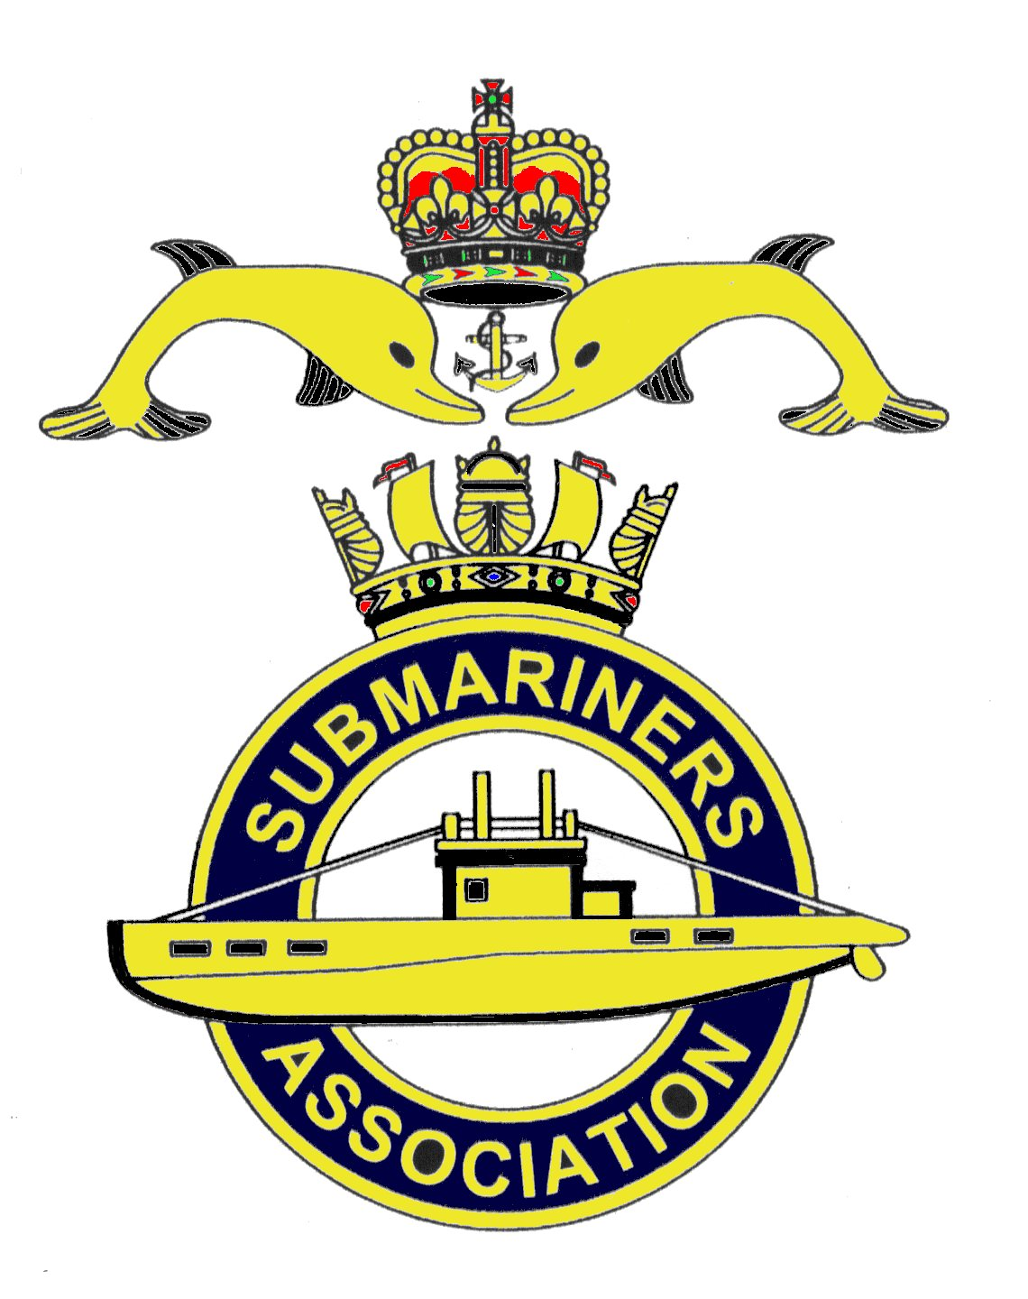  Lincoln Branch | Minutes of monthly meeting of Lincoln Submariners Association  At  The RNA Club  21st October 2018

- The Chairman opened the meeting at :-1235 and in doing so gave a special welcome to Adam Scott.
For personal reasons Adam has been absent from branch activities, but is now back with us.

- Members present :- There were 9 members present.

- Apologies:- Were received from, R.Elrick, J.Hobson, S.Unwin, T.Eynon, J.Serdecki,
P.Langdon-Manning. A.Last.

4. Obituaries: The secretary apologised for not getting a copy of the "In Memorium" sheet.
A minutes silence was held for those that have crossed the bar, followed by our prayer.
5. Minutes of the last meeting: The minutes of the last meeting were accepted as a true record.
6. Matters arising: There were no matters arising.

7. Chairman’s Report:
1) Discuss Blackpool &Fylde letter if required.
The Chairman was reminded that this letter had been read out at the September meeting and a copy
had been attached to the minutes of that meeting.
2) National Chairman's response to this letter.
This was read out to members, it concerns Blackpool & Fylde's letter " surfacing in the press courtesy
of social media."Again this letter was forwarded to all members on 5/10/2018. (It will be attached to
these minutes)
A short discussion took place about the merits of Virtual Reality and the fact that we have all got to
move on.
8. Correspondence:
There was no correspondence
9. Secretaries Report:
1) 2019 Diaries. These are now available, cost £2.20 each.
2) New Branch Standard carrying bag.
The meeting was told of the search by the Standard Bearer to find where a new bag could be obtained.
When a maker of these bags was found, the Chairman was told and his permission was given to go
ahead to get it made. On presenting the bag to the meeting for branch approval to pay for it, the
Chairman pointed out that he is allowed to spend £100 of branch funds. The Treasurer agreed that
a vote is not required.
3) Members Details.
Members were requested to keep the Secretary up to date with any changes in personal details,
address, phone number and E-mail address. etc.

10. Treasurer's report:-
Monthly Statement 16/09/2018
Opening Balance £3.211.78 Monies Paid out last month
Meeting collection £50.00 Diaries £39.60

Christmas Dinner £140.00
Bank Balance £3.362.18 Branch Balance £3.222.18

11. Social Secretary's Report:-
1) Christmas Dinner. All payments to be made by the November meeting.
The Social secretary will send booking form and Menu Choice to Adam Scott, who was also told the
format for the weekend.
A reminder will be sent out .
2) Chatham visit. Date for this visit is hoped to be sorted by the November meeting. A reminder
will be sent out.

12. Welfare:-
M.Brockelsby reported that Alex last is ok, and that he was hoping to bring him to the next meeting.

13. AOB:-
1) The Treasurer requests that all membership subscriptions are paid by the December meeting.
He does not intend having to chase people up for their sub's. The Chairman will send out a reminder.
2) Remembrance Parade on Saturday 10th November 2018 at 1030 - there will be a march past of 100 serving
members including Army, Royal Navy and Royal Air Force. Councillors, Freemen and Past Mayors
will be attending so it will be a tight fit to accommodate everyone bearing in mind it will be busy
with Saturday shoppers. Jack Hobson is laying our wreath at the memorial.
Those attending the Cathedral on Sunday, their places are reserved - only Jack and Avril are going.

There being no further business to discuss the meeting shut at 1315

NEXT MEETING SUNDAY 18th November 2018

Please be advised that these notes of the meeting made by the secretary cannot in any way be regarded
as the official minutes until they are approved and accepted at the next meeting.

