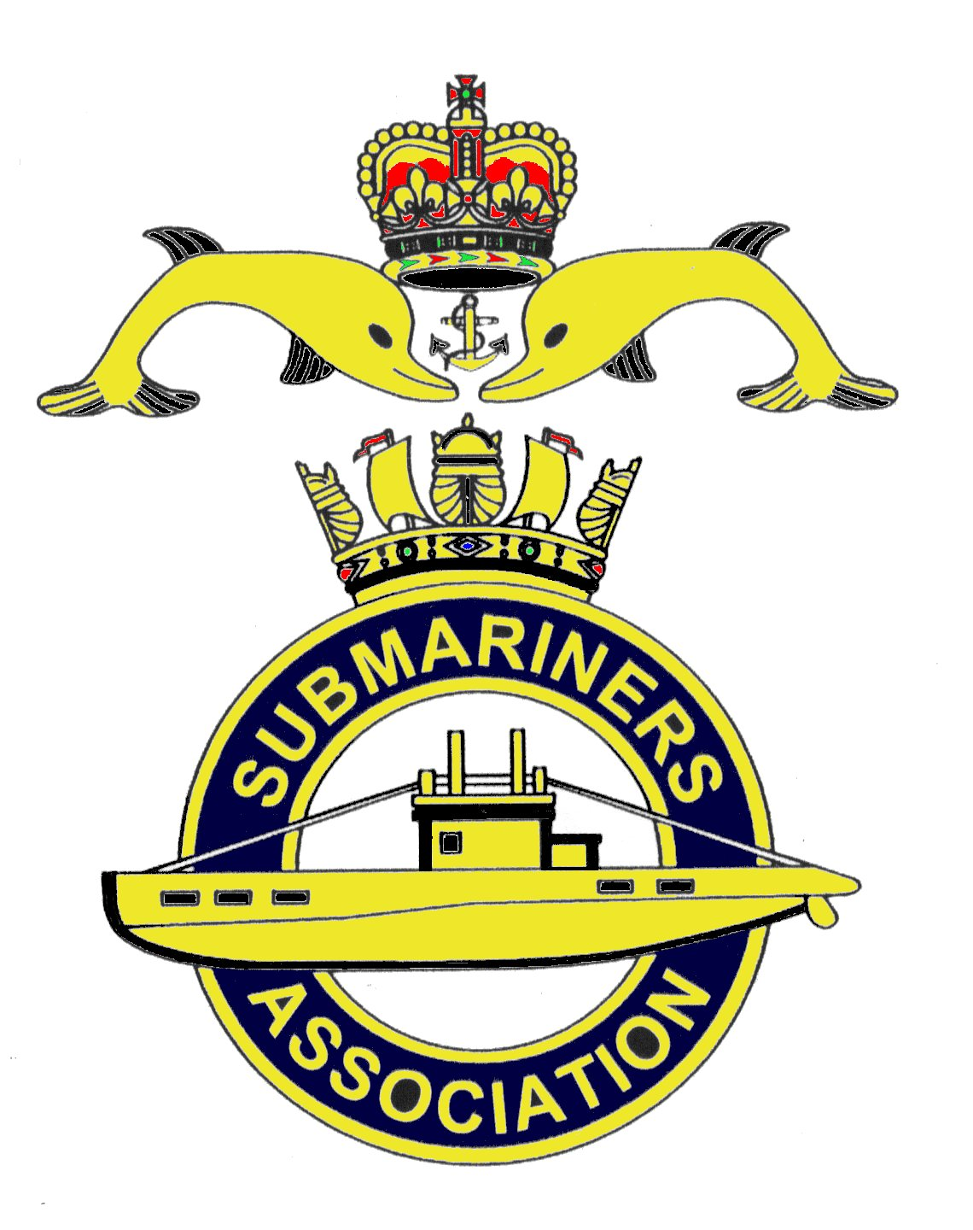  Lincoln Branch | Minutes of Monthly meeting of Lincoln Submariners Association  At  The RNA Club 17th November 2019

- The Chairman opened the meeting at :- 1240

- Members present :- There were 9 members present.

- Apologies:- Were received from, D.Bussey, A.Last, I.Stoney, F.Powell, R.Elrick, S.Unwin, G.Sheppard, J.Horton,

- Obituaries: "In Memorium" sheet was passed round for all to read, during which
a minutes silence was held for those that have crossed the bar, followed by our prayer.
After the "one minutes" silence, M.Williams said that he would be attending the funeral in Chichester
on the 29th November of CRS(SM) Les Stagpool who was a member of the Lostoppos website some years
ago. His photo hangs in the lounge bar of the club. Michael has taken our Branch Standard to parade.

- Minutes of the last meeting: The minutes of the last meeting were accepted as a true record.
- Matters arising: There were no matters arising.

- Chairman’s Report:-
1) Cancellation of December's meeting and proposal for January's meeting.
An E-mail received from the Chairman was read out:-
"I believe we should cancel December's meeting as it is the day following our Christmas Dinner.
We could then at our January meeting order in "finger food" and invite our families and friends to welcome in the
New year"
After a discussion between members it became obvious that they did not wish to make our January
meeting a party.
The Secretary asked for a show of hands to determine their wish that our meeting in January be as normal.
This proved to be unanimous. Therefore there will not be "finger food" at our January meeting.

2) Rum for Christmas Dinner.
E-mail received from the Chairman reads:-
a) Donation of Pusser's Rum for the Christmas Dinner for 30 members and guests (poss 3 bottles)
or we can pay out of our funds
b) Volunteer of a member attending the Christmas Dinner to bring the bottles of rum
c) Payment by all members to the Treasurer for the Christmas Dinner.
d) I will collect the RUM TUB from the RNA Club or someone else may volunteer to bring
it to the dinner.
Donations of Pusser's Rum have been received from, F.Powell, R.Elrick and M.Williams. And after
a discussion during which it was said that members thought that three bottles of rum would be enough.
The Secretary proposed that a fourth bottle was not required, this was seconded by M.Brockelsby.
This was carried unanimously.
As requested by the Chairman, M.Williams will order the rum from the RNA bar to keep costs down,
Michael also volunteered to take the Rum Tub to the dinner.

8. Correspondence:
1) E-mail from D.Bussey reads:-
" I have been made aware that the website doesn't display properly on a mobile and
sometimes tablets. I will endeavour to sort this but it's not a small job. I shall progress it in between
building my bungalow which is I'm pleased to say getting closer to completion."

9. Secretary's Report:-
1) As there is no meeting in December it has been requested that Association membership
fees be paid to the treasurer by the January 19th 2020 meeting.

10. Treasurer's report:-
1) As the Treasurer has not yet got full access to the Branch Bank account, he does not know
what the present balance is and therefore does not know what monies have been paid in for the Christmas Dinner,
or what the final invoice will be. A.Green has volunteered to take a signed/blank cheque to the dinner so that
the final invoice can be cleared on the night.
Bank Balance dated September £2770.18
Collected at this meeting £44.00
M.Brockelsby will advise the treasurer on managing the branch account.
M.Williams proposed that until things are sorted, all payments must be made via cheque to the Treasurer.

11. Social Secretary:-
1) E-mail reads:-
Payment by all members to the Treasurer for the Christmas Dinner.
This has been dealt with in the Treasurers report.

12. Welfare:-
1) M.Brockelsby is in touch with Alex - he is ok!
2) Members were reminded of Barbara Hunter's funeral on Tuesday 19th November 2019.

13. AOB:-
1) T,Eynon reported to members on his march at the Cenotaph on Remembrance Sunday in
London. It was an experience that he will never forget, and will do it again, despite it being a very long day.
Compared to the numbers of personnel in other units marching the turnout of submariners was poor, there being
only 16.
2) Paul (Shooter) Langdon-Manning, our serving member, having recently returned from a
CASD patrol reported that they had broken the record for days on patrol, 143!!

The meeting was shut at 1330.

NEXT MEETING SUNDAY 19th January 2020.

Please be advised that these notes of the meeting by the secretary cannot in any way be regarded as the official
minutes until they are approved and accepted at the next meeting.

Janet and I wish all members and their families a Merry Christmas
and a Happy New Year.

