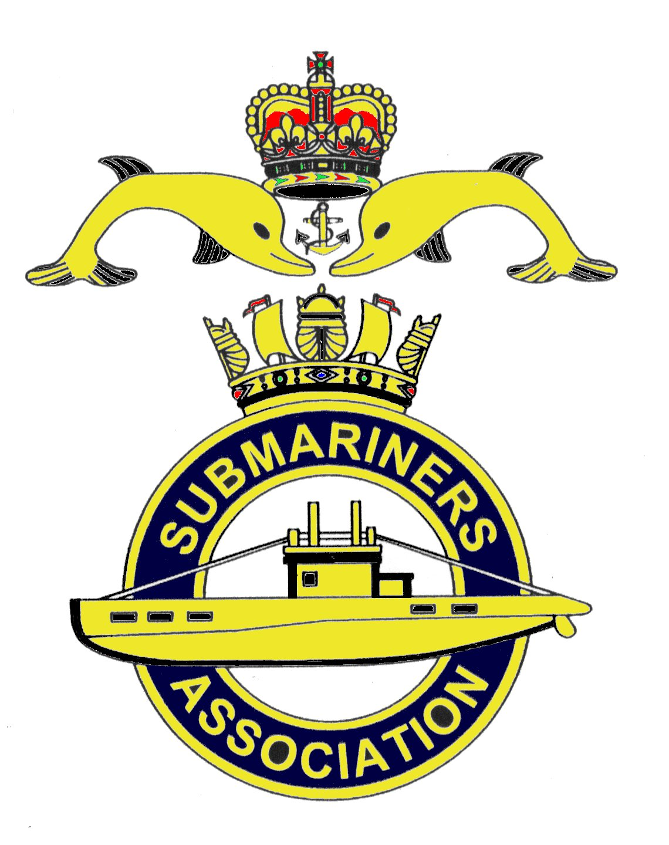  Lincoln Branch | Minutes of monthly meeting of Lincoln Submariners Association  At  The RNA Club 18th November 2018

- The Chairman opened the meeting at :-1230 welcoming members to the meeting.

- Members present :- There were 15 members present.

- Apologies:- Were received from, D.Bussey, S.Reader, J.Serdecki.

- Obituaries: "In Memorium" sheet was passed round for all to read, during which
a minutes silence was held for those that have crossed the bar, followed by our prayer.

- Minutes of the last meeting: The minutes of the last meeting were accepted as a true record.
- Matters arising: There were no matters arising.

- Chairman’s Report:
1) Submariner widows. It was proposed by our Chairman that it would be nice to invite the
widows of our members that have "crossed the bar" to join us at our Christmas nibbles
directly after our short Christmas meeting being held on the 16th December 2018. Members agreed
with this. The Chairman will try to contact, and send out an invitation to them all.
2) National Webmaster. David Woolterton is standing down as the national Webmaster,
due to work load. If anyone would like to volunteer to become the webmaster, please contact the
National secretary. (The E-mail regarding this was forwarded to all members.)
8. Correspondence:
1) Middle Temple E-mails. These E-mails were sent out to members of the NMC.
a) Gents, I would like to thank everyone for their contribution to what I believe was an excellent
Remembrance Service on Sunday 4th November. Every year another little bit of the jig-saw falls
into place and contributes to the bigger picture. The entire weekend was a great success. Thank
you all for your input. I will get down to sending all the "Thank you" letters to HRH et al.
Kind Regards. Jim McMaster ( Chairman Submariners Association)

b) Jim, May I echo your words and also say thank you and very well done to both you and to all
those who contributed so much in making the Remembrance gathering and indeed the whole
weekend the undoubted success it was. Everything went like clockwork and that only happens
after a lot of thought, attention to detail and a great deal of effort from all involved. HRH was a
star, stayed beyond his time and clearly enjoyed the occasion and meeting old and new. So BZ
all round and another "out hip flasks"
All the Best Niall (Rear Admiral Kilgour, President Submariners Association)

c) Dear Jim. Yesterday's SM Remembrance Service was a huge success. You fixed the weather
and everything ran perfectly. And it was totally obvious that HRH really enjoyed the occasion,
notwithstanding Jagerbomb issues!! (good to see the occasion well covered in the press - I presume
you have seen?)Actually, as always the media have been somewhat economical with the truth, but
all good fun PR. Anyway, I know how much hard work your team members put into making sure
that all would go well, so very many thanks and BZ to you all. It was a landmark event and most fitting
for the 100th Anniversary of the WW1 Armistice.
Best Wishes Mike. (Lord Boyce Patron of the Submariners Association)

2) Apologies.
Firstly, received from the wife of Rev, Mike Chapman.
Dear David, This is to let you know that my husband Michael is terminally ill and unable to attend
any meetings or special occasions. This is the reason he has not replied to e-mails for a while. I hope
you understand. We wish you a very Happy Christmas when it comes and hope you all enjoy the
Christmas Dinner. Best Wishes Bernadette Chapman.
Secondly received from Sean Reader.
Hi David. I won't be able to attend the meeting and sadly owing to work commitments I won't be
renewing my membership.I will in time come back to the fold when I have more time to commit and
be able to take a more predominant role. I have joined the RBL here in Scunthorpe so I'm still doing
my bit ensuring the Army and RAF veterans know that submariners are best.
My regards to you all. We'll meet again. Yours aye, Sean.
Finally, This e-mail sent from John Gray, who submitted an application to join the Lincoln
Branch of the Submariners Association.
Dear David, Thanks for your prompt reply and correspondence but I have, after much thought and
deliberation, decided not to continue my request to join the Lincoln Branch of the Submariners
Association. I feel that I would not be able to attend meetings due to the location and my other
commitments and there would be little value in me joining if I could not become a fully integrated
member and join in all your meetings and social gatherings. Thanks again for your greetings and very
welcoming correspondence. I wish you all well and trust that you and the members continue to
enjoy the association benefits. Kind Regards John Gray.

9. Secretary's Report.
1) Standard Bearer's Report. Gentlemen, Since our last meeting on 21st October your
Standard has been paraded 5 times, supported each time by my wife, Janet.
Firstly at the Trafalgar night celebrations at this club on the night of 21st October. Our Chairman
attended and at one point had the lady entertainer sat on his knee.(Julia doesn't know this!) John and
Sarah Horton, Michael and Jackie also, Michael with the RNA Standard.
Secondly at the Submariners Association memorial parade that took place on the 4th November at
Middle Temple Gardens in London. This was attended by our Commodore in Chief HRH Prince
William the Duke of Cambridge who joined the parade in the toast to "absent friends" and joined
guests in the main hall afterwards. Photo's of the service were available on the Daily Mail on line,
and a video was on Youtube. Serving members, veterans and 13 standards paraded. Rick, Sandy
and Andy Jeffrey travelled down to London for the parade.
Thirdly I attended a Concert of Remembrance given by the Lincolnshire Fire and Rescue concert
band at Robert Pattison Academy, North Hykeham on the 9th November in support of the RBL
Poppy Appeal. Once again I was supported by our chairman and his wife Julia. Michael paraded
the RNA standard.
Next, on the 10th November the memorial service took place at the War Memorial, High St, Lincoln.
Serving members of the armed forces marched down the High St. Jack Hobson laid our wreath.
Our President Rick, Chairman Sandy were joined by Roger Frankish, he having travelled into Lincoln
from Barnetby. (Having missed the order to "left turn" to march off, Bungy got my attention just in
time to march off with everyone else!!)
Finally at 1300 on the 10th November following the parade on the High St, there was a wreath
laying ceremony at the War memorial in Newport cemetery, where 6 Standards were paraded
including the RNA Standard.
The Chairman thanked all those that turned out.

2)Christmas meeting food, Jack and Avril have volunteered once again to get the nibbles
from Sainsburys. It was agreed that £50/£60 be spent

10. Treasurer's report:-
Monthly Statement 21/10/2018
Opening Balance £3.362.18 Monies Paid out last month
Meeting collection £36.00 UJC Acc Standard Bearer £68.50
Christmas Dinner Payments £1,045.00 Rail fare Embankment Parade £41.80
Membership Fees £60.00 Branch Standard New Case £60.00
Diaries Receipts £39.60 Postage £15.50
Wreath £34.00
Bank Balance £4,322.98 Branch Balance £3,077.98
Amount Collected at this meeting £63.00

11. Social Secretary:-
1) Christmas Dinner. The Chairman reported that the wine had been ordered, and his donation
of Port was given to Rick for the dinner. Although the branch voted not to have a raffle, the Chairman
has donated a bottle of Scotch, that he said we can raffle at either the Christmas dinner or our meeting
on the 16th December. Bottles of Rum have been donated by S.Unwin, M.Williams and A.Jeffrey.
The Loyal Toast will be given by Ade Green and the departed Toast by John Horton.
2) Chatham visit. Date for this visit has been fixed for 17/18 May 2019.

12. Welfare:-
M.Brockelsby reported that Alex last is ok, but having trouble with his legs.

13. AOB:-
1) The Treasurer requests that all membership subscriptions are paid by the December meeting.
Branch Bank details are:- Barclays Bank. Account No:- 33816125 Sort Code;-20-50-21
and the amount is £15.

There being no further items for discussion the meeting was SHUT at 1309.

NEXT MEETING SUNDAY 16th December 2018

Please be advised that these notes of the meeting by the secretary cannot in any way be regarded as the official
minutes until they are approved and accepted at the next meeting.

