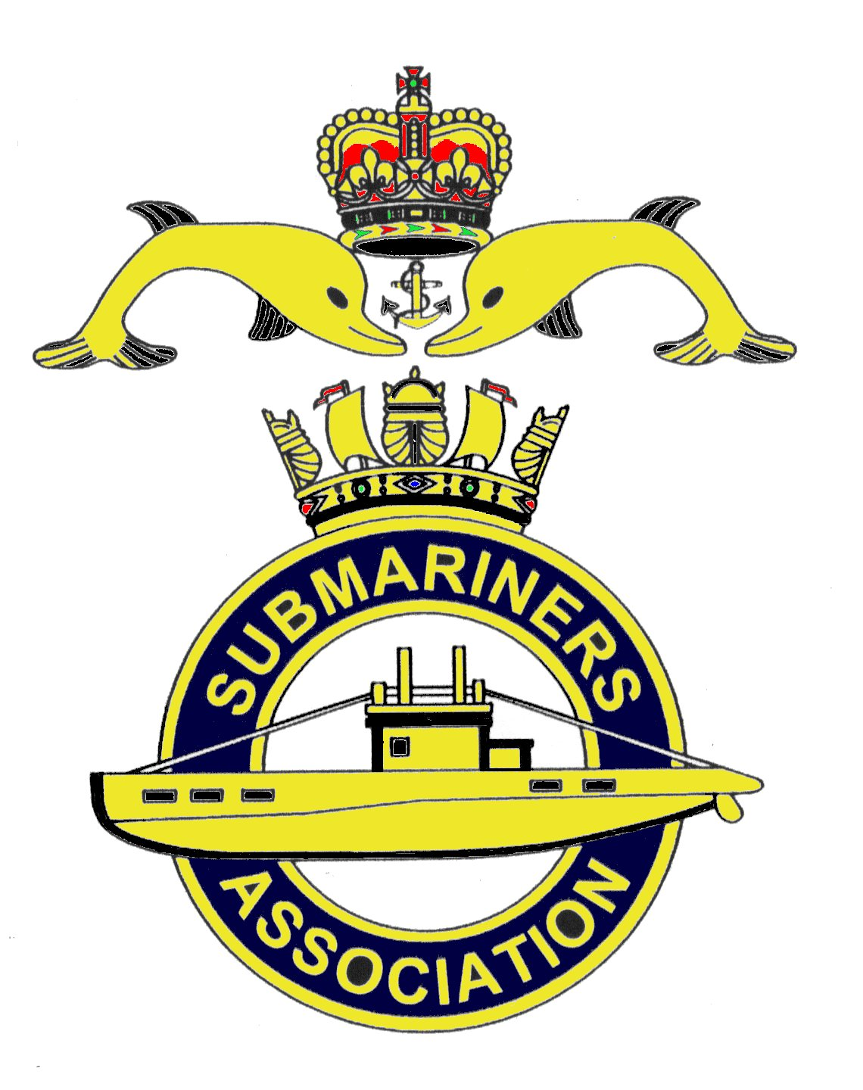  Lincoln Branch | Minutes of monthly meeting of Lincoln Submariners Association  At  The RNA Club 17th March 2019

- The Chairman opened the meeting at :- 1230

- Members present :- There were 11 members present.

- Apologies:- Were received from, D.Bussey, S.Unwin, A.Last, P.Langdon-Manning.

- Obituaries: "In Memoriam" sheet was passed round for all to read, during which
a minutes silence was held for those that have crossed the bar, followed by our prayer.

- Minutes of the last meeting: The minutes of the last meeting were accepted as a true record.
- Matters arising: There were no matters arising.

- Chairman’s Report:- Nothing to report

8. Correspondence: None

9. Secretary's Report:-
1) Please be reminded that April's meeting has been brought forward one week, and will
now be held on 14th April 2019.

10. Treasurer's report:-
Monthly Statement 17/02/2019
Opening Balance £2,875.14 Monies Paid out last month
Meeting collection £30.00 D-Day Wreath £34.00

Branch Balance £2,871.14
Amount Collected at this meeting £48.24

11. Social Secretary:-
1) Christmas Dinner
a) Letter from Nottingham Branch thanking us for the invitation to join Lincoln Branch
for Christmas dinner was read out. Unfortunately they are unable to join us due to other functions.
b) Options for venue of our Christmas Dinner 2019.
Option 1. Hemswell Court An Ex RAF officers mess.
3 course Christmas dinner at £35 per head, if Cheese and biscuits are to be included the cost is £38.50.
Room per night £100 to include breakfast. We can take our own rum, but as the cost of a bottle of wine
is £24, it was suggested that if Hemswell Court is chosen, individuals buy their own wine, and not as in
previous years when paid for by the branch. The date chosen is Saturday 14th December 2019.
Option 2. Lincoln Hotel.
3 course Christmas dinner at £34 per head. Standard room £85 to include breakfast. Corkage is £20 per
bottle and house wine at a discounted price of £17 per bottle.
£10 per person deposit, non-refundable, at time of booking.
The date available is Saturday 14 th December 2019.

Option 3. Does anyone wish to return to South View Hotel at Skegness.

A vote was taken on the three options put forward, with Hemswell Court being chosen as the venue for
our Christmas dinner 2019.
The social secretary will send out all relevant information, menu etc.

2) Branch Lunch Outings.
The Social secretary put forward the idea of branch members meeting for lunch at the Woodcocks Pub,
Burton Waters, Lincoln. The date of 10th April was suggested and agreed upon. An E-mail will be sent out
asking members to confirm their intention of attending this.

3) New Veterans ID card. This was forwarded to all members on the 20th February 2019
4) CASD50 Ceremonial Divisions 5th July. Forwarded to members on 10th March 2019
5) SM Advisory Group Annual Report January 2019, Forwarded to members on 10th March 2019

12. Welfare:-
M.Brockelsby reported that Alex Last is ok, he sends his regards to all.
J.Hobson reported that Barbara Hunter had sustained a broken rib from a bad fall, her step-daughter
Carol is looking after her. It was agreed that a card and flowers be sent to Barbara.
Jack also raised the condition of Rev Mike Chapman. The Chairman will make contact with the family.

13. AOB:-
M.Williams reported that the rumours going around Lincoln that AFD has been cancelled, are false,
AFD Lincoln 2019 has not been cancelled.
He also reported that the unveiling of Ensign from HMS Maenad will take place at the RNA Club
on Thursday 30th May 2019, this is the closest date to the actual Battle of Jutland that can be arranged.
Invitations are to be sent out, dress will be No 1's with medals, Standards are not required.
Mike reminded everyone of the collection dates for AFD, they are 6th April and the 1st June. Volunteers
muster at the War Memorial, High St, Lincoln at 0900. Dress No1's with medals.

There being no further business the meeting was shut at 1315.

NEXT MEETING SUNDAY 14th April 2019

Please be advised that these notes of the meeting by the Secretary cannot in any way be regarded as the
official minutes until they are approved and accepted at the meeting.

