Lincoln Branch Submariners Association

Minutes of meeting held on:-Sunday 20th March 2016
1.Chairman opened the meeting at:- 1240
2.Members present:- There were 15 members present.
3.Apologies:- Received from:- S.Unwin. J.Hobson, D.Bussey, T.Eynon, S.Hemingfield, G.Sheppard
4.Obituaries:-The list of Obituaries from the last month were passed round for all to read.
5.Minutes from the previous meeting:- The Secretary stated that he wished to amend the minutes, in that he had mis-quoted J.Hobson,in his presentation for the Pyewipe Inn, by saying that "a £10 deposit is payable on booking", this is incorrect, it should read, "a £10 deposit is required when choice of menu is given, approximately 2 weeks in advance.
It was proposed by M.Williams and seconded by M.Brocklesby that these minutes be accepted.
Unanimously Agreed.
6.Matters arising:- The Chairman stated that he had read all E-mails whilst on holiday, and that the report made by the Vice Chairman and noted in the minutes, "the sum of £800 had been spent by the branch to provide wine for our table", was not correct. He then passed out copies of his breakdown of money spent on wine over a 4 year period. He asked for this to be included in the minutes.
He understands that we have done away with the wine, which he thought was a" bloody good idea" - and that we have done away with the Port also, which he donates. The branch were aware that the Chairman donated the Port, as it was stated at the February meeting. If we had waited for him to return from holiday before taking the vote he would probably have again paid for the Port and corkages. Unfortunately, due to other commitments he will be unable to attend this Christmas Party. (Please see Profit/Loss table below.)

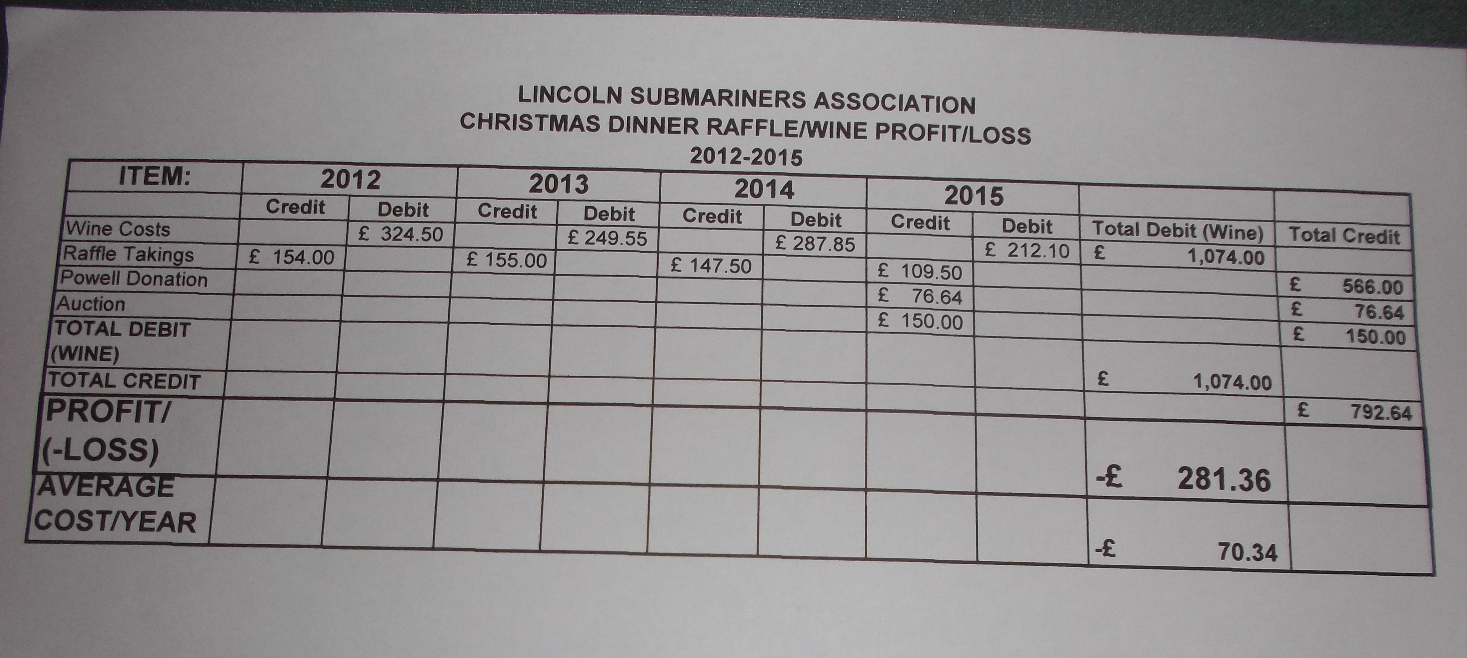

7.Chairman's report:-
1) Donation to National President leaving fund. The Chairman read out the E-mail from the National Secretary regarding the stepping down of Admiral Sir James Perowne as our President, to be relieved by Admiral Niall Kilgour. Donations can be sent to the National Treasurer, to be towards a gift from the Association. The N.M.C. are giving an engraved decanter, glasses and a bottle of malt whiskey.
It was proposed by M.Brocklesby that the branch donate £20 to the National President's leaving fund. Carried unanimously. M.Brocklesby to send a cheque and card from the branch to the National Treasurer.
2)April National Reunion/A.G.M/-Proposals/Recommendation.
Proposal No1.
Proposed by Sunderland Branch. Seconded by North-East Branch
We propose that a member of the Association may apply for suspension/waiver of the annual subscription due to the criteria agreed by the N.M.C; the Membership Secretary be empowered to waive said subscription for the annum in question, such waiver to be reviewed at a later date Members that may be considered for suspension/waiver of subscriptions may include.
a) World War 2 Veterans Supported
b)Members that find themselves unemployed. Not Supported
c)Members of an age where they are unable to
pay and are in full time care. Not Supported
d)Members that find themselves down on their luck Not Supported

Proposal No2
Proposed by Barrow Branch Seconded by Morecombe bay Branch
We propose that the N.M.C should ensure that the total costs of the Submarine Memorial Parade and associated activities is limited to 40% of the current year's subscriptions.
Not Supported
Proposal No3
Proposed by Merseyside Branch Seconded by Plymouth Branch
It is proposed that the N.M.C (Treasurer) makes available, within one month of the N.M.C meeting, a breakdown of the N.M.C Expenditure to the members of the Association. This should be a comprehensive and detailed account and should show increases in expenditure from the previous year. i.e. train fares, hotel costs etc.
Not Supported
Proposal No 4
Proposed by Plymouth Branch Seconded by Merseyside Branch
It is proposed that the existing system of One Branch one vote, be changed to and replaced with One member One Vote. In doing so we believe this would ensure that a fair and democratic result being achieved in all future Ballots held by the Association.
Not Supported

Proposal No 5
Proposed by Dolphin Branch Seconded by Medway Towns Branch
The Dolphin Branch proposes that an additional paragraph, 5(f) (a) be added to Clause 5 (f) of the Rules & Constitution.
Existing Clause 5(f): The cost of all National Council Conference meetings, and National Council members' approved travel expenses shall be a charge against the funds of the Association
Proposed addition:5(f)(a) Where the Conference and a Reunion are held at the same place and time. Travel expenses of National Council members who are attending the Reunion cannot be a charge against the funds of the Association.
Supported
Recommendation
The National Management Committee will recommend;
"Members of the Association who are permanently non-UK residents should pay a reduced Annual Subscription. The amount recommended is 1/3 of the in place Subscription, and that the Submariners Association Rules & Constitution, Clause4, be amended to accurately reflect this decision."
A reduced Annual Subscription for Spain Is not Supported by the Lincoln Branch
The Branch does not support 1/3 reduction of the in place Subscription. However, a proposal for an amount of 50% of the in place Subscription was put forward and was accepted, to apply to all other non-UK residing members of the Association.
John Horton, our delegate, will be making these proposals and recommendation on our behalf at the National A.G.M.

National Management Committee Members.
There are four applicants for the two positions on the N.M.C they are:-
Mark Butchart Barrow-in-Furness Branch
Chris Freeth Bath Branch
Andrew Morgan Welsh Branch
Brian Tate West of Scotland Branch.
All four applicants case for acceptance was discussed by members, with views given by members that knew any of them.
It was decided by a show of hands that the Lincoln Branch propose that the two nominees are;- Chris Freeth and Brian Tate

At this point the Chairman was requested to leave the meeting, as he is one of the two nominees for position of National Vice Chairman.
The two nominees are, Edward Hogben and Frank Powell
It was proposed by R.Elrick and seconded by M.Bugg that Frank Powell be proposed by the Lincoln Branch. Carried Unanimously

3) Lincoln Branch A.G.M- Committee/Officers position.
The Chairman stated that he needs a rest, and therefore at our A.G.M in May, the positions of Chairman and Social Secretary are up for grabs. However, all members can express their desire to serve on the committee at the A.G.M.
8.Correspondence:-
1) Sea Sunday will be held on Sunday July 24th at All Saints Church, Monks Road, Lincoln at 0930. Standards to muster at 0900 for briefing.
9.Secretary's report:- Nothing to report.

10.Treasurer's report:
Monthly Statement 21/02/2016
Opening Balance £3,094.35
Meeting Collection £47.00
Associate M/Ship Fee £5.00
M/Fees £337.50

Monies Paid out Last Month
M/Fees- Chairman,Secretary,Treasurer £45 to National
M/Fees £337.50 to National

Branch Balance £3,101.35

11.Social Secretary's Report:-
The Nottingham Branch are hosting a social, similar to the one held by us, when Nottingham and Hull branches joined us for an afternoon of entertainment, good food and drink .We, along with Leicester, Derby, Peterborough and Hull branches have been invited to join them on Saturday 14th May starting at 1130. The venue is The Mill, Bagnall Rd, Basford, Nottingham. NG6 0JY. A maximum attendance by Lincoln members would be good and appropriate. a coach is being arranged for this social by the Social Secretary.
.
12.Welfare report:- Nothing to report.

13.LExSA report:-
LExSA meeting was held on Thursday 18th February 2016, our rep' Michael Williams was unable to attend. It was their AGM and the out going Chairman David Gratrick was re=elected for a further term.
Michael Williams investigated why there was no money carried over from the 2015 A.F.D to this year. He was informed that the figures are correct, although a sum of £74 for taxi fares needs to be investigated further.

Regarding the Memorial Railing Fund- Donations have not been returned, except for the W.R.N.S who particularly requested that theirs should be. All donations should be returned to all donors, instead it is sitting in LExSA accounts. At the next meeting that he is able to attend, he will raise the issue of these funds.
M.Williams then asked if he could just say that the R.N.A/Club A.G.M on 18th March was poorly attended, with only 5 full members present, that included himself and the Chairman.
But went on to praise the hard work done by the Club Committee ,Bar Staff, Treasurer etc. This is the first time in the 13 years that he has been a member, that the club posted a surplus. This surplus was £3500. It is down to where we are sitting, this room is our cash cow.
He then reported that the club have been unsuccessful in their bid to the Armed Forces Covenant Fund for a grant to repair the club roof. However, the club must move forward and repair the most damaged parts of the club.
R.N.A Diary

On the 30th May there will be a Battle of Jutland B.B.Q
On the 31st May a Battle of Jutland service will be held at the war Memorial
On the 3rd June a Battle of the Somme service is being held. (Standards will be required)

A.O.B.
R.Elrick reminded that next months meeting is being one week early, due to Club booking of the function room.

Meeting shut at:- 1425
Date of next meeting:- 10th April 2016

Please be advised that these minutes of the meeting taken by the Secretary cannot in any way be regarded as the official minutes until they are approved at the next meeting.

.

.

