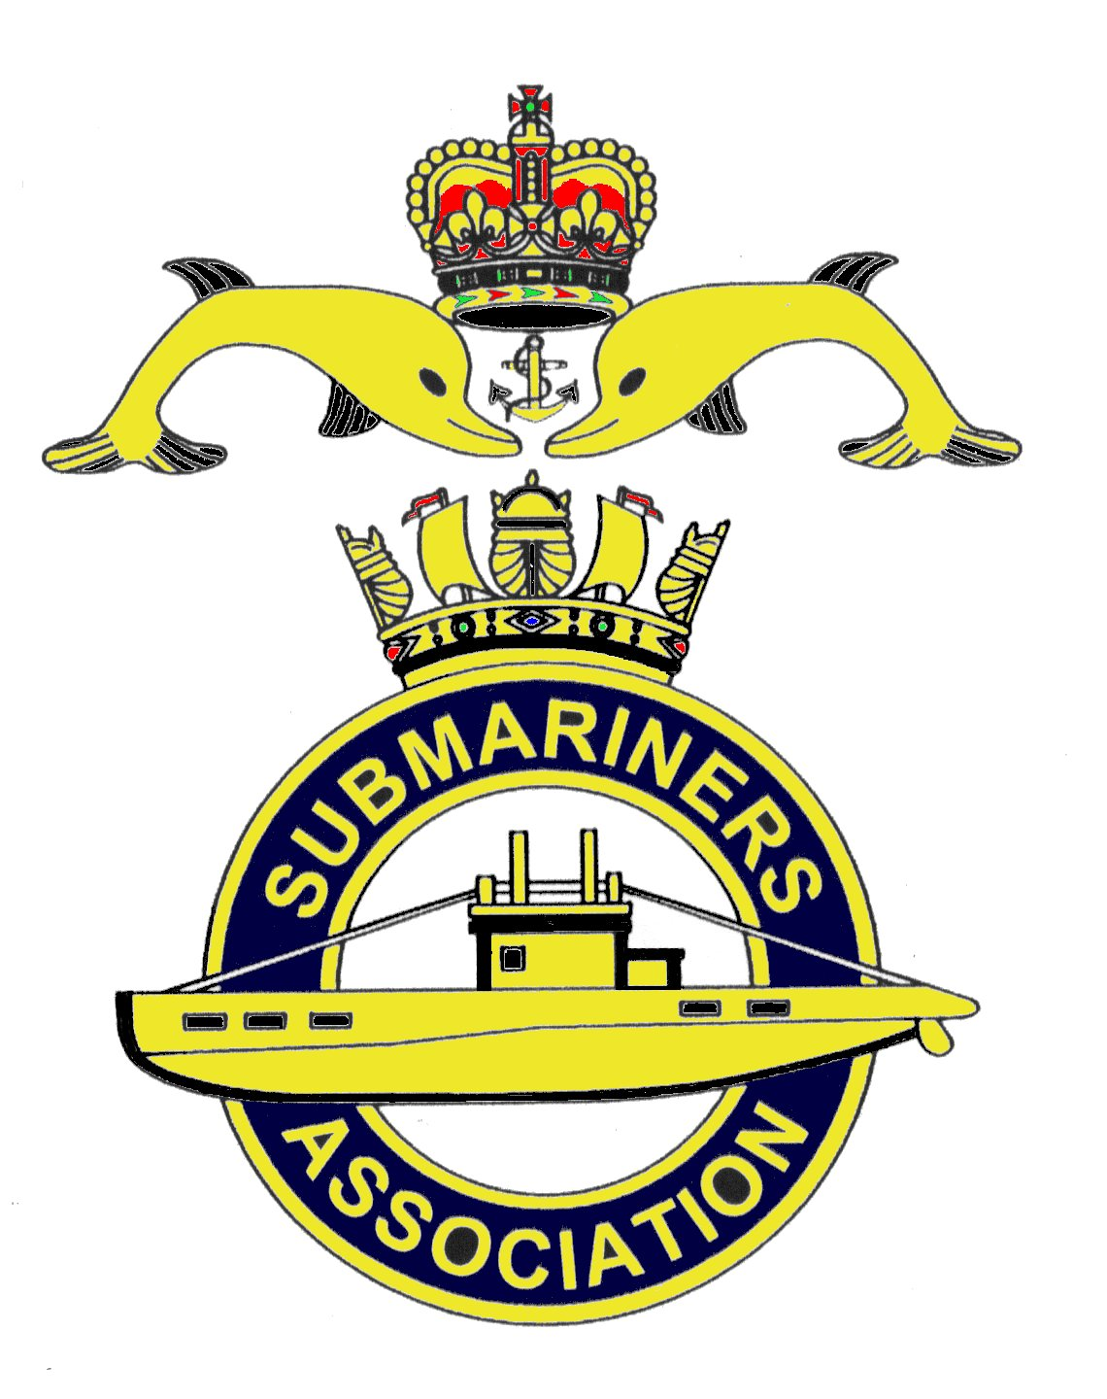  Lincoln Branch | Minutes of monthly meeting of Lincoln Submariners Association  At  The RNA Club 20th January 2019

- The Chairman opened the meeting at :- 1235

- Members present :- There were 12 members present.

- Apologies:- Were received from, D.Bussey, A.Jeffrey, S.Unwin, A.Edwards, A.Last, J.Serdecki.

- Obituaries: "In Memorium" sheet was passed round for all to read, during which
a minutes silence was held for those that have crossed the bar, followed by our prayer.

- Minutes of the last meeting: The minutes of the last meeting were accepted as a true record.
- Matters arising: Confirmation was given that our April meeting will be on the second Sunday
14th April 2019.

- Chairman’s Report: The Chairman had nothing to report.

8. Correspondence:
1) The letter that accompanied our Christmas donation to the Lincs and Notts Air
Ambulance was read to members attending:-
"Please accept this cheque for £100. Air Ambulance being our chosen charity at our
annual Christmas meeting. We admire the great work you do. Happy New year to you all"
9. Secretary's Report:-
1) Membership report. Members were told that we have lost one member, he being
Robert (Bob) Seymour . Bob lived in Cleethorpes but he finds the travelling too much for
him to fully take part in the branch activities. We wish him well!
Membership stickers for 2019 were handed out, these to be attached to your membership cards.
The Secretary will send out stickers to members unable to attend this or future meetings.
2) Christmas Dinner 2018. Report by the Secretary.
Our Christmas Dinner at Skegness was a very enjoyable weekend. It was attended by 21 members and guests. Our President Rick led the proceedings, including the singing. The meal was washed down with copious amounts of alcohol and the usual dities, songs and stories followed by much bawdy
laughter.
We remained in the private room which added to the great friendly atmosphere.
On Sunday morning a bleary eyed group met up in the conservatory to be served with an excellent breakfast. This meal washed down with copious amounts of tea and coffee.
Refreshed and happy we parted after expressing our goodbye's. A good start to our Christmas

The Chairman then added that he would send a letter of thanks to Southview Park Hotel.

3) Christmas Party 2018. Report by the Secretary.
Eleven members joined family and guests for our Christmas Party. Only one invited widow was
able to join us. Barbara Hunter was accompanied by her step daughter Carol and husband Terry.
Rose Davies ( widow of our friend Walter) had rung previously with her thanks for the invitation,
unfortunately she is now too frail to attend. She wished all members a Merry Christmas.
Nibbles were collected by Avril and Jack Hobson, and raffle prizes donated by members were
displayed. A decision had been made that the bottle of whiskey donated by our Chairman be
raffled separately. 40 tie-on labels were attached to the neck of the bottle, each numbered, and for £1
names were attached. The barman had been asked to chose a number between 1 and 40 to be kept secret.
£40 was raised, and the winner was a member of the Social Club.
The Christmas cake made and donated by our Chairman was cut by Chris Unwin and passed round,
appreciation was voiced. The raffle was drawn thus ending a very enjoyable time.
It was suggested that for our 2019 Christmas Party we provide the nibbles ourselves. This
was agreed.

10. Treasurer's report:-
Monthly Statement 16/12/2018
Opening Balance £3,199.63 Monies Paid out last month
Meeting collection £39.80 Xmas meeting food £45.50
Xmas meeting raffles £121.00 Xmas meeting drinks £45.10
Membership Fees £30.00 Air Ambulance Donation £100.00 Postage stamps £37.79
Membership Fees £330.00
Branch Balance £2,832.04
Amount Collected at this meeting £43.10

11. Social Secretary:-
Our Social Sec' reminded all those that are going on the trip to Chatham Dockyard, that this
takes place on the 17/18 May 2019.

12. Welfare:-
M.Brockelsby will visit Alex Last after the meeting

13. AOB:-
1) The Social Sec' listened to remarks made concerning the venue for our 2019 Christmas
dinner. Do we want to go back to Skegness? Where ever we go we must bear in mind our needs.
ie. Corkage, Rum and Private room. And due to the decline in numbers attending, it was suggested that
we invite one of our local branches to join us. Nottingham Branch was chosen, and our Chairman will
write inviting them.
2) Monthly lunches. Do we wish to start having these again, if so, members were asked to
come to the February meeting with ideas.
3) M.Williams reported that at the forth coming meeting of LExSA to be held on the 23rd it
is expected that it will fold.
4) M.Williams informed the meeting that the funeral of George Philpott (Ex R.M) will take
place on Tuesday 22nd January 1310 at Lincoln Crematorium. Our Standards will be paraded
This follows the funeral of Barry Stonham ex FAA that took place at Lincoln Crematorium on
8th January 2019 with internment at Waddington burial site. Standards were paraded and accompanied
by serving members.
5) M.Williams informed the meeting that the Jutland Ensign from HMS Maenad that had until
now been kept folded had now been completely refurbished and preserved and framed. It is to be hung
on the wall at the RNA club, and an unveiling ceremony will take place with family and ancestors of
the man that presented it to the RNA Club. He was a Leading Tel on the Maenad.
6) Finally from M.Williams, 2019 RNA sub's are now due, £14.
7) The Secretary reported that details of a new member wishing to join the Lincoln Branch
were received from the Membership Secretary. But despite sending an E-mail of "welcome" with
branch details, there has been no response yet. Michael Limming served in submarines 1981-2000.
8) Finally, our Chairman gave an update on forth coming Blue Plaque events that he is in
process of arranging.
9) Apologies were received from J.Hobson for February's meeting.

There being no further business, the meeting was shut at 1312.

NEXT MEETING SUNDAY 17th February 2019

Please be advised that these notes of the meeting by the secretary cannot in any way be regarded as the
official minutes until they are approved and accepted at the meeting.

