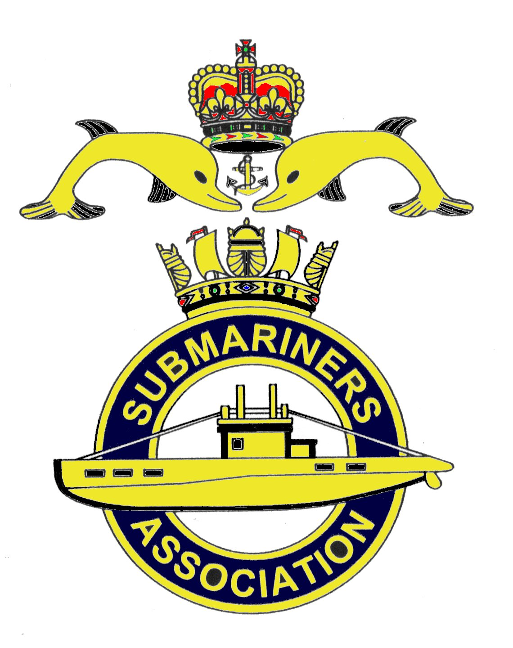  Lincoln Branch | Minutes of monthly meeting of Lincoln Submariners Association  At  The RNA Club 17th February 2019

- The Chairman opened the meeting at :- 1232

- Members present :- There were 8 members present.

- Apologies:- Were received from, D.Bussey, A.Jeffrey, S.Unwin, A.Last, J.Hobson, A.Green.

- Obituaries: "In Memorium" sheet was passed round for all to read, during which
a minutes silence was held for those that have crossed the bar, followed by our prayer.

- Minutes of the last meeting: The minutes of the last meeting were accepted as a true record.
- Matters arising: There were no matters arising.

- Chairman’s Report:
1) Delegate for National Council Conference. Our President Rick Elrick will oblige.

2) Proposals and Recommendations at the Council Conference.

Proposal No1. Creation of a new Memorial at the National Arboretum (NMA) as per TOF
SUBDIV
Proposed by: Norfolk Branch Seconded by: Manchester Branch
Norfolk Branch believes that the case for a new and fitting memorial at the NMA for all
submariners who have lost their lives on duty has been made and that it should be led by RASM
through SUBDIV supported by the SA
NMC comments.
This is in RASM'S hands. "This is a National Issue and does not require a vote"

Proposal No2.
Proposed by: Norfolk Branch Seconded by: Manchester Branch
STRATEGIC REVIEW OF COMMEMORATION
There are many submarine memorials scattered across the country from the National Submarine
War Memorial on the Embankment in London to the Affray Memorial on Alderney - altogether
around 50 on RASM's list. With this number a strategy needs to be developed for who attends
what, when, for what purpose, and under whose leadership. The strategy should take into
account a number of factors including, but not limited to:-

- Importance - national, regional, local
- Relevance - how relevant to serving and veteran personnel today
- Relatives, survivors - are any still alive and will they attend
- Environment - suitability for contemplative remembrance
- Local facilities - catering, accommodation, prayer....
- Cost - to the service, the SUBDIV, the SA and attendees
- Media interest - local, regional, national, international.
- Links to other national events
- Access and accessibility
- Ability to cope with intended numbers.
The Submarine Memorial which is intended to be built at the NMA will need to be worked
into this strategy but so will other memorials. The review should be completed by the time the new
memorial is opened so as to allow a seamless transition.

NMC comments: "This is a National Issue and does not require a vote"
A review was carried out several years ago. At the time the NMC was restricted to certain memorials
due to cost and Branches were encouraged to maintain a presence at local memorials services as they
saw fit.

Proposal No 3

Proposed by: Barrow Branch Seconded by: Morecambe Bay Branch

The Barrow in Furness Branch will propose that Clause 9(d) of the Rules & Constitution Issue 6 be
amended as follows:
The existing clause remains with an addition to read: "Only Full Members of the Association who
have achieved their BSQ AND SUBSEQUENTLY have served in (any) 'commissioned' Royal Navy
submarine for a period not less than 12 months including a minimum of one SSBN Patrol or 3 months
at sea in a SSN or in a SSK are eligible for election.

The full amended clause 9(d) will therefore read:-
(d) Each elected member of the National Management Committee shall hold office for a term
of three years, two of whom being elected in each calendar. Only Full members of the Association
who have achieved their BSQ AND SUBSEQUENTLY have served in a commissioned submarine
for a period not less than 12 months including a minimum of one SSBN Patrol or 3 months at sea in a SSN
or in a SSK are eligible

NMC comments
The NMC are happy with this, as it covers a situation that could arise in the future.

LINCOLN BRANCH SUPPORT THIS PROPOSAL

Proposal No4

Proposed by: Scottish Branch Seconded by: Blackpool Branch

Change to Clause 9:- National Management Committee. Section(b)

The National Management Committee shall be made up of:- 1. The Chairman 2 The Vice Chairman
3. The Treasurer 4 The National Secretary 5 The Membership Secretary 6 Six other members elected
according to the procedures set out in 9(h) 7 Another Member nominated in accordance with clause 9(j)

Elected Members shall upon their election to the National Management Committee relinquish / suspend
any Committee position they might hold on any Branch committee of the Submariners Association until
such time that their NMC position expires.
Background Information
Quotes...........Although presently each individual member of the NMC is properly elected to the National
Committee, the proposal will avoid a conflict of interest. the NMC members more truly independent
in their decision making process without any ties to the management of individual branches.

NMC comments
If this goes through it will rule out most of the NMC as most have two or more jobs in the association
Branches. This could in some cases result in the closure of Branches due to lack of volunteers.
LINCOLN BRANCH DOES NOT SUPPORT THIS PROPOSAL.

Proposal No 5

Proposed by; Scottish Branch Seconded by:

3) Addition to Clause 10 - Branches

Voting procedures at individual Branches to include the facility of postal voting on all matters pertaining
the Branch, election of Branch Committee members and proposals to be submitted by the Branch to the
National Secretary for the annual AGM/Conference. This should also include voting on the Proposals of
other Branches and Recommendations from the NMC submitted for the Annual Conference of the
Submariners Association.

NMC comments
A Branch may use any means to canvas their members on NMC proposals and recommendations. This
could be at the Branch meeting, by email, post or any other means to get the opinion of it's members. The
Dolphin Branch have no meeting, everything is done by email or post. The Branch then has one vote at the
conference if there is a representative. Branches who do not send a delegate lose their vote. The only
exception is overseas Branches who can send in a postal vote to the National Secretary to read out at the
conference.
Lincoln Branch support this Proposal

Recommendations.

Recommendations 1and 2 Have been removed.

Recommendation 3.

The National Management Committee will recommend that:-

Clause 4 - Subscriptions

All sub-section nomenclature be changed from numerical to alpha notation.
Sub-section (b) be amended to read:

Any member not paid by the First of March will be deemed a "Lapsed" member. A New Application Form
will not be required to re-join until a period of 1 Year has passed since the member lapsed.

Last sentence to read:
A member will be deemed to be a Life Member in the year that they reach the age of 90 and exempt them
from paying National Subscriptions.

THIS RECOMMENDATION IS SUPPORTED BY THE LINCOLN BRANCH

Recommendation 4.

The National Management Committee will recommend that:

Clause 5 - The National Council

Sub-section (a) amended to read:

(a) The policies of The Association shall be vested in the National Council, which shall meet for it's
Annual Conference during the Annual Reunion Weekend but with access to the Conference limited to
Full members only, and as near as possible to 31st March each year, or at such time the National
Management Committee may decide.

Paragraph (d) amended to read:

(d) Branch delegates on the National Council shall each have one vote at meetings of the National
Council. If a member of the NMC's branch does not have a delegate on the council, then the NMC
member may take that role and vote on behalf of his branch.
No other member of the National Council shall have a vote.
The Chairman of the meeting shall have a casting vote if equal number of votes are cast for and against
a resolution. (Where a simple majority vote is required.)

Observers will be segregated from the branch delegates to allow votes to be counted. Under Clause 5(f)
no Observers will be entitled to expenses from the Association funds.

THIS RECOMMENDATION SUPPORTED BY LINCOLN BRANCH.

Recommendation 5

The National Management Committee will recommend that:

Clause 9 - National Management Committee
Paragraph (b)(vii) amended to read:
One other member nominated in accordance with clause 9(i)

Paragraph (g) amended to read:
(a) The President and Vice Presidents shall be invited to participate in National Management Committee
meetings with the Vice Presidents having full voting rights.

Paragraph (h)(iii) amended to read:
Ballot papers for the election or re-election of candidates shall be sent to branches by the National Secretary
no later than 6weeks before the date of the National Council Conference.

THIS RECOMMENDATION SUPPORTED BY LINCOLN BRANCH.

ANNEX B

National Management Committee (NMC) Members.

There are only two applicants for two positions on the NMC. No vote required.

The applicants are:-
Brian Tate NMC West of Scotland Branch
Mark Smith West of Scotland Branch.

8. Correspondence:
1) Letter received from the Lincs and Notts Air Ambulance reads:-

"On behalf of the team here at the Lincs and Notts Air Ambulance I would like to thank you and
everyone who contributed towards the generous donation of £100. Please find enclosed a certificate in
recognition of everyone's kindness and generosity."
Kind Regards Mrs Gemma Shaw.

9. Secretary's Report:-
1) Chatham Visit, as this falls on the weekend of the Branch 2019 AGM (19th May)
It has been decided to move the May meeting to the 26th May 2019

10. Treasurer's report:-
Monthly Statement 20/01/2019
Opening Balance £2,832.04 Monies Paid out last month
Meeting collection £43.00 Membership Fees £30.00
Membership Fees £30.00

Branch Balance £2,875.14
Amount Collected at this meeting £30.00

11. Social Secretary:-
1) Referring to the monthly lunches, the Social Secretary suggested that we have a lunch at
"The Woodcocks" pub, which is situated at Burton Waters, Lincoln. Choosing a date in March proved a
little difficult. It was then suggested that we postpone choosing a date until next month when it is hoped
that more members will be present.

12. Welfare:-
1) M. Brockelsby reported that Alex Last is ok!

13. AOB:-
1) The Social Secretary reported that he had sent an invite to the Nottingham Branch, inviting
their members to join us for our Christmas Dinner 2019. They do not appear to be interested, and have not had the decency to respond to the written invite sent to them
Do we wish to have a Christmas Dinner 2019? If so, we must decide where we want to go by the
next meeting on March 17th. Our Chairman has put forward going to Hemswell Court, he will get details of
cost etc. The Secretary has offered to approach the Lincoln Hotel once again, and report at the next meeting.
2) Chatham visit. Details can be found on the Dockyard website regarding a tour held visiting
sites where "Call the Midwife" (TV Series) had been filmed. The cost of this tour is £25 per head.
Cost for entry to the dockyard is £22.50 with concessions at £19.50. Group bookings can
be made at a cost of £14.50 per head. The Social Secretary will gather all information and send it out to all
those travelling to Chatham.
3). M.Williams reported that LExSA has ceased exist. At the final meeting the funds that were held
were divided between the four branches that attended. Three of these branches have donated this money to
the AFD funding.
The next AFD meeting will take place on 4th March 2019. There will be two collecting days in Lincoln for
AFD, volunteers are needed to help, the days being;- Sat 6th April and Sat 1st June. Muster at the War Memorial
on Lincoln High Street at 0900, No1's with medals.
3) The Ensign form HMS MAENAD a destroyer that saw action at the battle of Jutland has now
been mounted on the bulkhead at the RNA Club. It has been preserved at a cost of £500, which has come
from RNA Funds and not Lincoln Branch. It is planned to hold an official unveiling ceremony as close
as is possible to the 103rd anniversary of "Jutland", 31stMay-1st June 1916. All depending on the availability
of family, ancestors and VIP's.
4) M.Williams also informed the meeting that a service will take place at 1045 on Thursday 6th June
to commemorate the 75th Anniversary of D Day. Our Chairman has obtained a wreath which he will lay on
behalf of the Lincoln Branch.

There being no further business, the meeting was shut at 1334.

NEXT MEETING SUNDAY 17th March 2019

