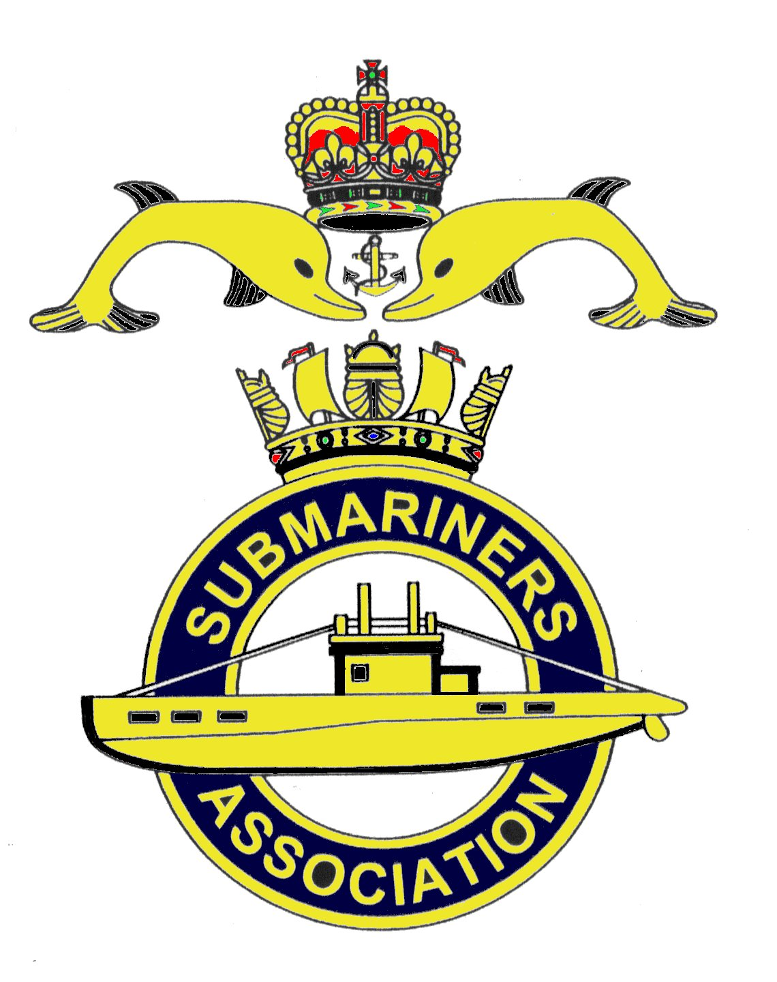  Lincoln Branch | Minutes of monthly meeting of Lincoln Submariners Association  At  The RNA Club 16th December 2018

- The Chairman opened the meeting at :- In the Chairman's absence our President Rick Elrick opened the meeting at 1240

- Members present :- There were 11 members present.

- Apologies:- Were received from, D.Bussey, T.Eynon, A.Green, G.Sheppard.
With their apologies came Christmas greetings to all members.

- Obituaries: "In Memorium" sheet was passed round for all to read, during which
a minutes silence was held for those that have crossed the bar, followed by our prayer.

- Minutes of the last meeting: The minutes of the last meeting were accepted as a true record.
- Matters arising: There were no matters arising.

- Chairman’s Report:

8. Correspondence:
1) Letter from Lt Com. David Brannington R.N (Equerry to HRH The Duke of Cambridge)
This letter was read out to members present. A copy is attached.
9. Secretary's Report:-
1) Charity for this year. It was decided by members that we support the Lincs and Notts Air Ambulance again this year. A cheque for £100 made payable to Lincs and Notts Air Ambulance was given to the secretary for him to post.

10. Treasurer's report:-
Monthly Statement 18/11/2018
Opening Balance £4,322.98 Monies Paid out last month
Meeting collection £63.00 Trafalgar Night rum £57.90
Christmas Dinner payments £382.50 Christmas Dinner £1567.50
Membership Fees £195.00 Christmas Wine £120.45
Parking Fee £18.00
Bank Balance £3.199.63 Branch Balance £2,944.63
Amount Collected at this meeting £39.80
11. Social Secretary:-

12. Welfare:-

13. AOB:-
1) Due to bookings made at the RNA Social Club our April meeting has been moved to the
2nd Sunday which is 14th April 2019
2) A card with "thoughts, prayers and best wishes" was to be sent to Rev Mike and Bernadette
Chapman from the branch.
There being no further items for discussion the meeting was SHUT at 1300

NEXT MEETING SUNDAY 20th January 2019

To all our families and friends I wish you all a very Happy New Year.

