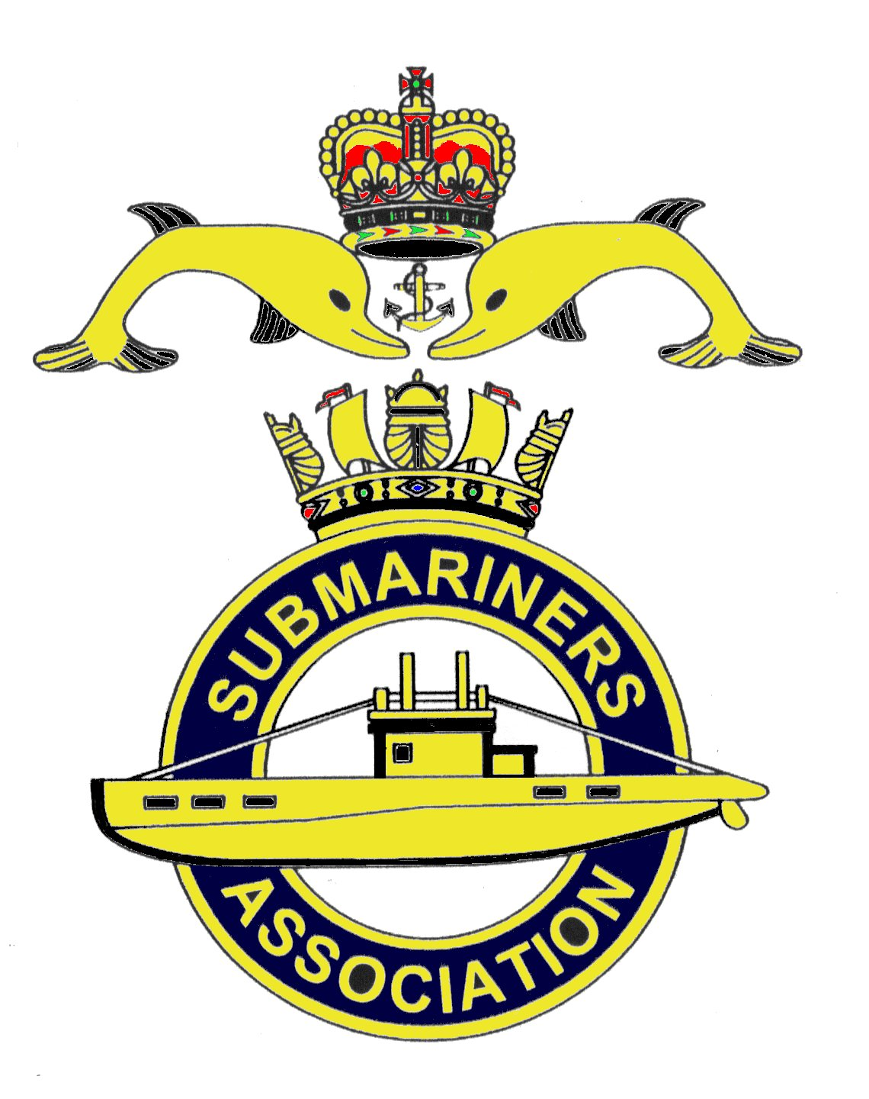  Lincoln Branch | Minutes of monthly meeting of Lincoln Submariners Association  At  The RNA Club 14th April 2019

- The Chairman opened the meeting at :- 1235

- Members present :- There were 11 members present.

- Apologies:- Were received from, D.Bussey, A.Last, P.Langdon-Manning.D.Shaw, J.Serdecki.

- Obituaries: "In Memorium" sheet was passed round for all to read, during which
a minutes silence was held for those that have crossed the bar, followed by our prayer.

- Minutes of the last meeting: The minutes of the last meeting were accepted as a true record.
- Matters arising: There were no matters arising.

- Chairman’s Report:-
1) Venerable Mike Chapman. The Chairman thanked those who had attended Mike's funeral. The
church was packed with mourners including 3 Bishops and several members of the clergy
The Chairman congratulated Mike Williams and David Willcock, both stood with their Standards for the
whole length of the service, a period of one and a half hours.
Mike was laid to rest in the church yard in the manner of a priest.
The wake was held at the White Heather Restaurant. A letter of thanks from Bernadette Chapman was read
out..

8. Correspondence:
1) The secretary read out a letter of invitation to members to attend the unveiling of
H.M.S. Maenad's Ensign from the Battle of Jutland, that will take place on Thursday 30th May 2019 at the
RNA Club commencing at 1400. Members wishing to attend are asked to let the secretary know so that
numbers can be given to M.Williams for catering purposes. ( This letter was forwarded to all members on
14th April 2019 )

9. Secretary's Report:- All relevant information having been forwarded to members, there is nothing to
report.

10. Treasurer's report:-
Monthly Statement 17/03/2019
Opening Balance £2,871.14 Monies Paid out last month
Meeting collection £48.24 Christmas Dinner Deposit £300.00
Branch Balance £2,619.38
Meeting Collection £47.00

11. Social Secretary:-
1) Christmas Dinner. The Social Secretary was amazed at the number wishing to attend, he had
24 names down with 9 rooms booked (These might change)
A discussion followed as to whether Dinner Suits could be worn, M.Williams said that it was either one or the
other and not a mixture of both. The Social secretary decided on a vote, Dinner suit or Blazer and medals. The
decision was Blazer and medals to be worn.

2) Chatham Trip.
The Social Secretary ran through the list of those going.

12. Welfare:-
1) M. Brockelsby reported that Alex is ok.
2) J. Hobson said that he was in contact with Barbara Hunter, and since her fall she does not get out.
She is getting financial help, and is happy with this. The Chairman asked Jack to keep in touch.

13. AOB:-
1) As no details have yet been published Rick Elrick (our delegate at the AGM) reported that he had
voted as the Branch had indicated. This was followed by a lengthy discussion between members.
2) The Chairman informed members about the "Patrons Commendation" given to Rick Elrick in
recognition of his hard work and dedication for the Submariners Association.
3) The 2020 AGM and Reunion will take place at Yew Lodge Hotel, Kegworth. Leicestershire. on the
weekend of 27/30 April.
4) Mick Brockelsby reported that as he is standing down at our AGM ( May 26th ) he will give copies
of his Annual Financial Statement to Chairman, Rick and the Secretary.

There being no further business to discuss the meeting was shut at 1320

NEXT MEETING SUNDAY 26th May 2019 to include our AGM.

Please be advised that these notes of the meeting taken by the Secretary cannot in any way be regarded as the

official minutes until they are approved and accepted at the next meeting.

